Module 7 Homework
John Doll
10/23/2020

1. Generate a map of your home location
#getting ohio map
map.county <- map_data('county')
ohio.county <- subset(map.county, region=="ohio")
#hometown coordinates
wapak_df <- data.frame(long=-84.19408, lat=40.56894)
#US map
states_map <- map_data("state")
#plot of my hometown
ggplot() +
geom_polygon(data = states_map, aes(x=long,y=lat,group=group), fill="white", colour=
"black") +
geom_point(data = wapak_df, aes(x = long, y = lat)) +
annotate(geom="text",x=-84.19408,y=40.56894, label="Wapakoneta",adj=-0.05, color="red")+
theme_nothing()
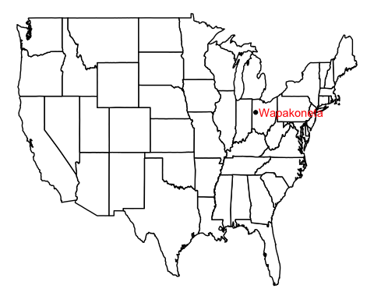

2. Generate a choropleth map of Ohio and shade counties by their case rate per thousand
#get corona cases from ohio.gov
ohioDF <- read_csv("https://coronavirus.ohio.gov/static/COVIDSummaryData.csv")
#get ohio population from census.gov source = https://www.census.gov/data/datasets/time-
#series/demo/popest/2010s-counties-total.html#par_textimage_739801612
ohioPop <- read_excel("co-est2019-annres-39.xlsx")
view(ohioPop)
#get the date
Today <- Sys.Date()
#filter out row of totals and mutate variables
ohioDF <- ohioDF %>%
filter(Sex != "Total") %>%
mutate(OnsetDate = mdy(`Onset Date`)) %>%
filter(Today - OnsetDate <= 30) %>%
group_by(County) %>%
summarize(ncases = sum(`Case Count`))
#filter out unneeded rows and columns before combining tables to leave just the 2019 population
ohioPop <- ohioPop[5:92,13]
view(ohioPop)
#combine tables and changing variables
#rename county to subregion to map it with ohio.county
#https://www.sharpsightlabs.com/blog/rename-columns-in-r/
combinedOhio <- cbind(ohioDF, ohioPop) %>%
mutate(countyPop = as.double(`...13`)) %>%
select(!`...13`) %>%
mutate(rate = (ncases/countyPop) * 1000) %>%
mutate(County = str_to_lower(County)) %>%
rename(subregion = County)
#combine all data sets into one
rateDB <- merge(ohio.county, combinedOhio, by.x = "subregion", by.y = "subregion")
#map
ggplot(data = rateDB, aes(x=long,y=lat,group = group, fill=rate)) +
geom_polygon(color = "black") +
scale_fill_gradient2(low="#559999",mid="grey90",high="#BB650B",
midpoint=median(rateDB$rate)) +
labs(title = "Ohio COVID-19 Infection Rates per 1000 Residents over the last 30 Days",
subtitle = paste("Updated: ", Today)) +
theme_map() +
theme(legend.position = "right")
